METALCO MFG., INC.
700 West 20th Street

Hialeah, Fl 33010

305 592-0704 Fax 305-805-2299

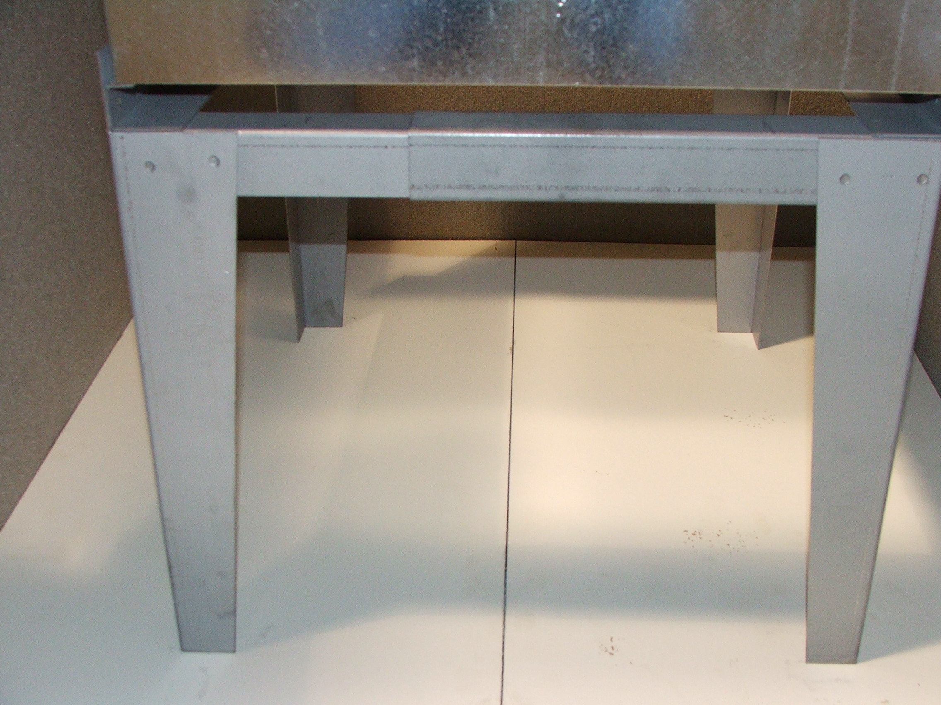 | TG-18  Air Handler Base 22”Depth, 16” To 26”Wide, 18”High

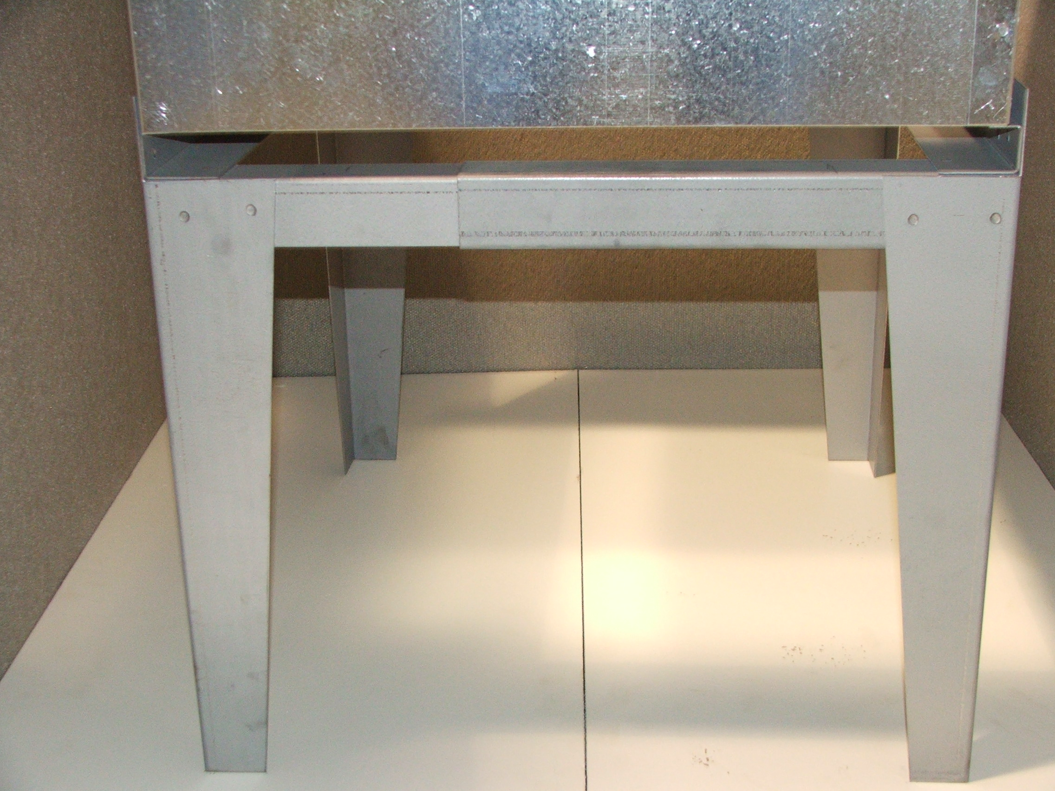 | TG-25  Air Handler Base 22”Depth, 16” To 26”Wide, 24”High

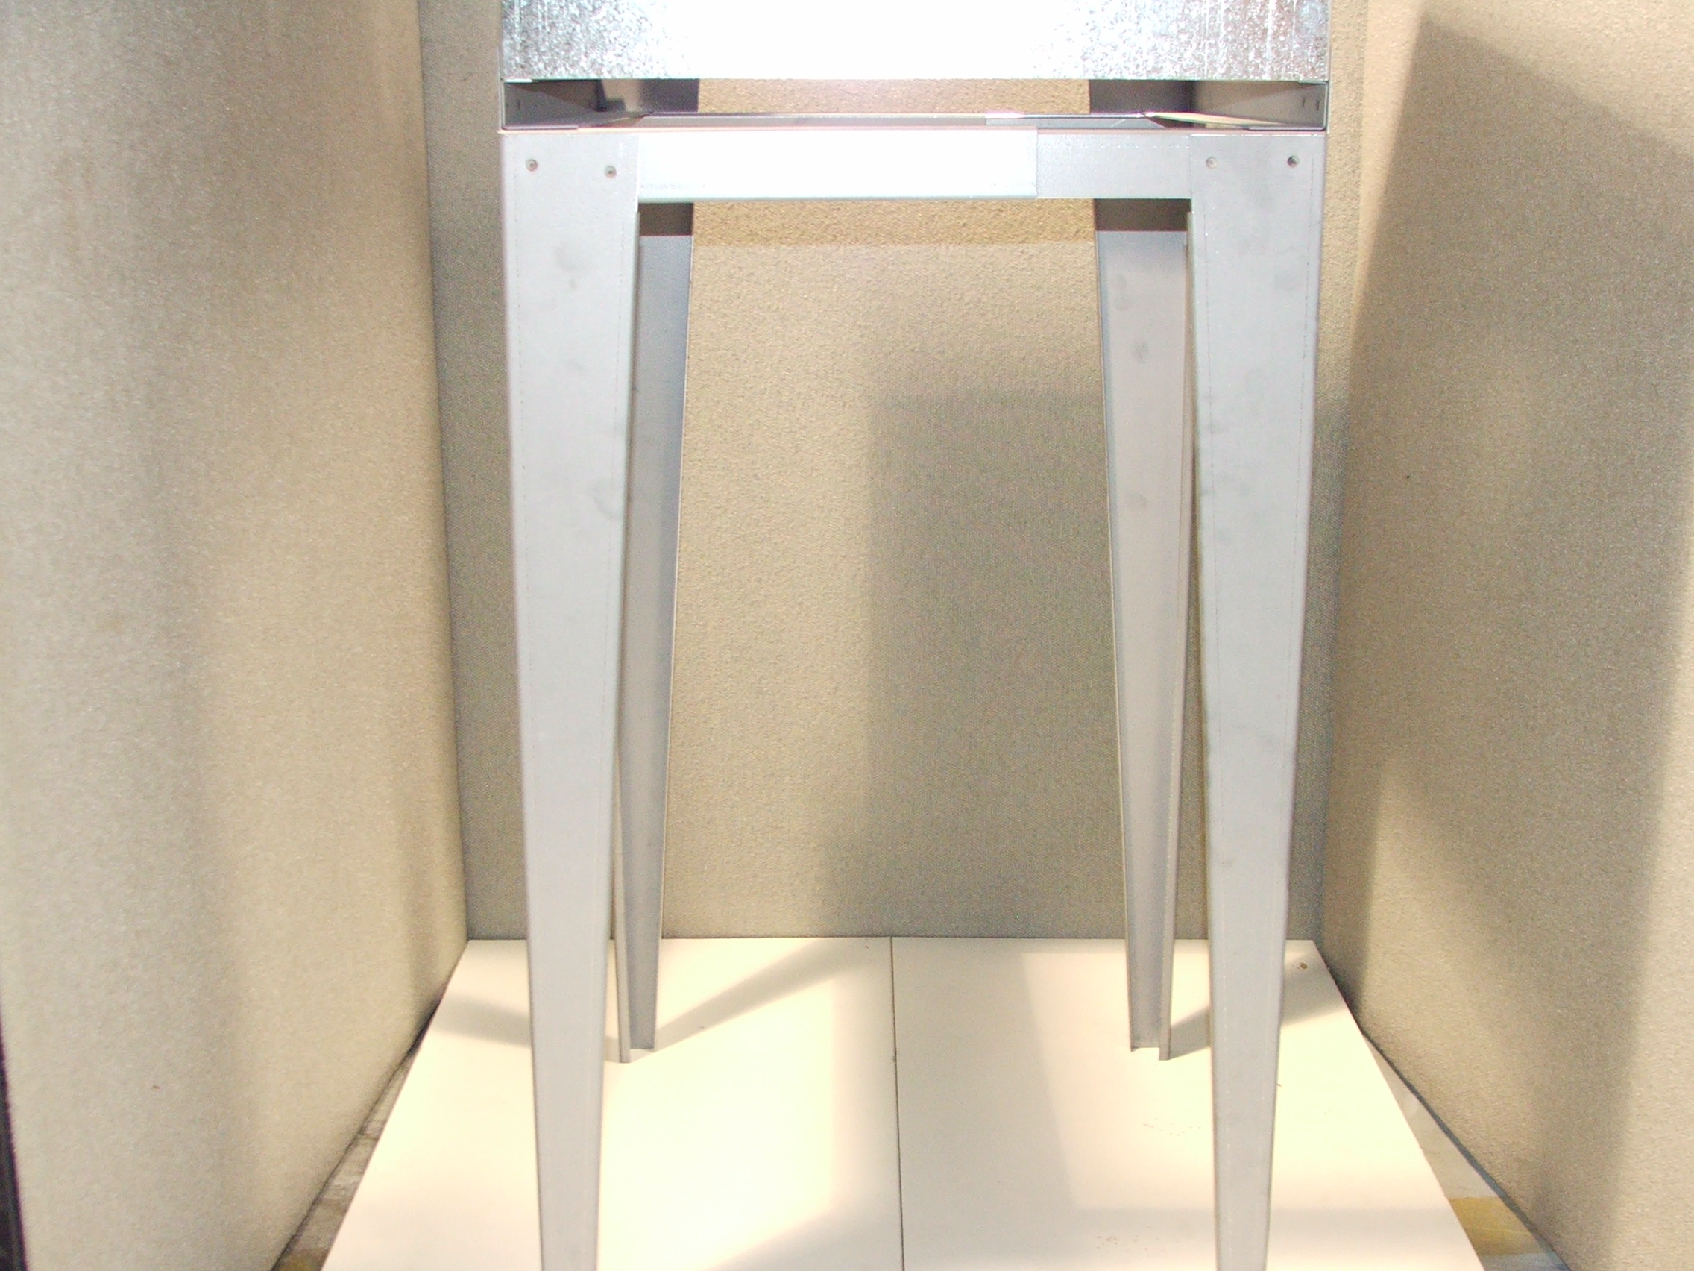 | TG-36  Air Handler Base 22”Depth, 16” To 26”Wide, 36”High

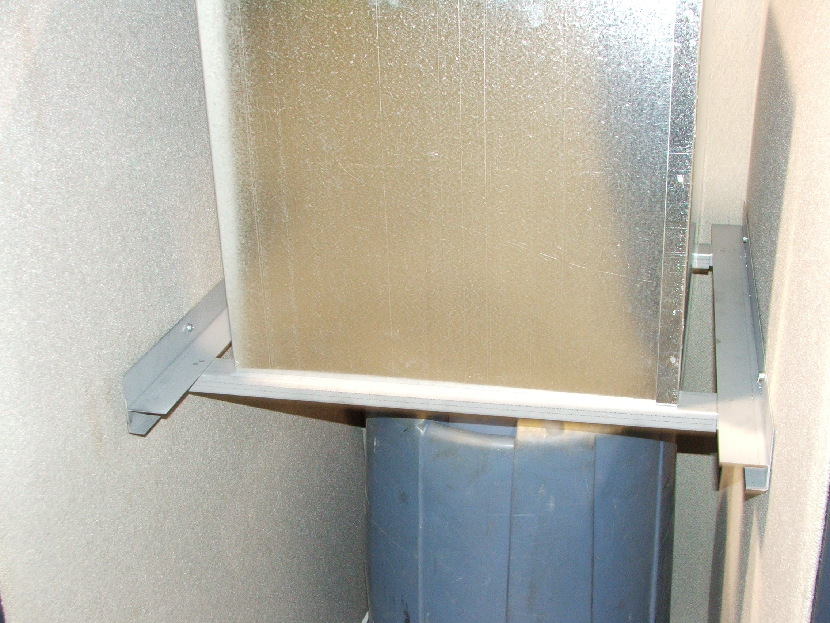 | Wall Rack For Air Handler Unit  24”Depth, 20” To 28” Wide, For 16” AHU & Up

Wall Rack For Air Handler Unit
30”Depth, 27” To 36” Wide, For 22” AHU & Up

TG-SP And WR-SP Must Call For Price:
(Specialty Item’s) Made To Size

